All Module Posters: Cafeteria, Restroom, Playground, Hallway
Respectful | Responsible | Safe
  Wait your turn | 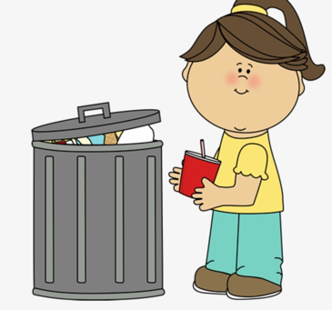  Place trash in can | 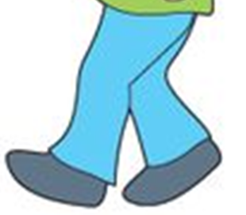  Use walking feet
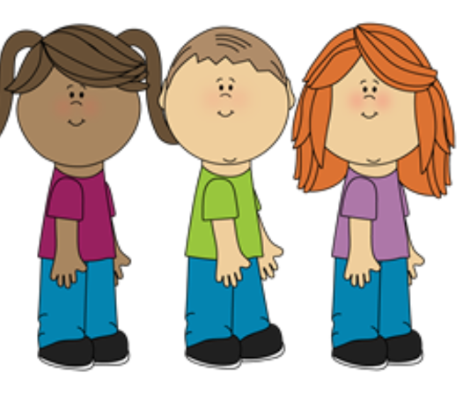  Hands and feet to self | 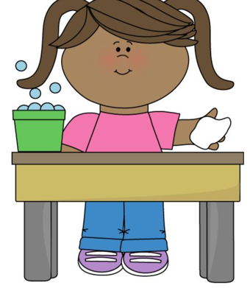 Clean up space | 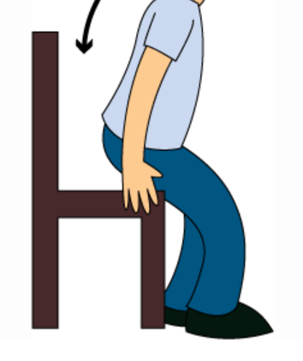  Sit at assigned table

Cafeteria

Restroom
Respectful | Responsible | Safe
Wait your turn | Place trash in can | Use walking feet
Hands and feet to self | 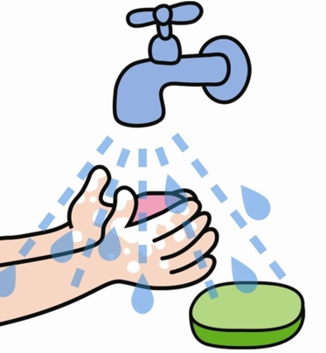  Wash hands with soap

Playground
Respectful | Responsible | Safe
  Wait your turn | 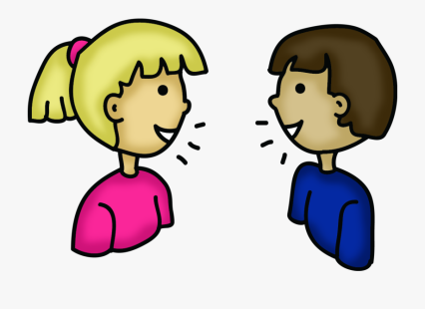Use your words | 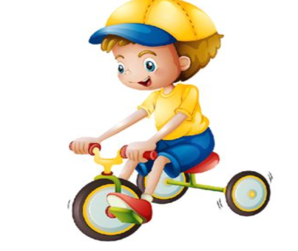Use equipment as taught
 | 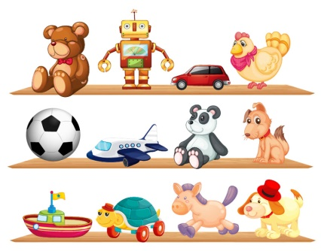Put equipment back

Respectful | Responsible | Safe
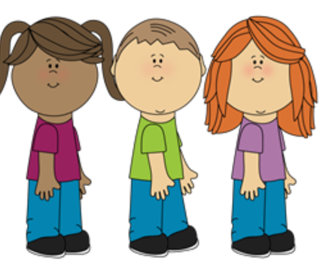Hands and feet to self | 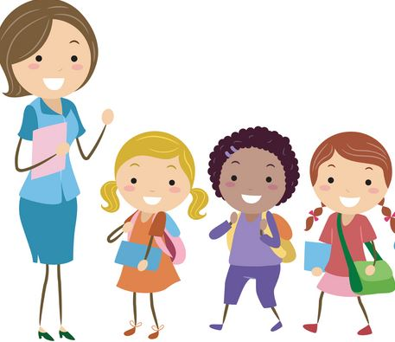  Follow directions | Use walking feet
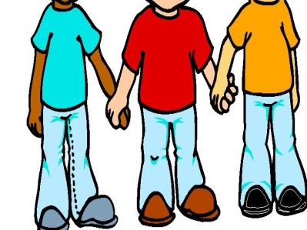
Stay Together

Hallway

