# Ohio Local Preschool’s Responding to Challenging Behavior System

**(A team’s sample of how they developed their specific system that worked for their building.)**

Table of Contents

Ohio Local Preschool’s Responding to Challenging Behavior System 1

1. Behavior Definitions: 2

2. When is a behavior Safe? (TFI refers to Classroom Managed) 3

3. When is a behavior Unsafe (TFI refers to Office Managed) 3

4. What defines a challenging behavior? 3

5. Flowchart 4

6. Continuum of Consequences (Strategies) 5

7. Behavior Incident Report & Guidance 6

8. Guidance on the Process for Data Collection for Data Based Decision Making 12

## Behavior Definitions:

|  |  |  |
| --- | --- | --- |
| **Behavior** | Definition | Examples (what it might look like / sound like) |
| **Noncompliance** | Refusing to following directions | Running away from an adult or class  Dropping to the ground (limp noodle)  Hiding (under tables, under lockers, etc.)  Refusing to transition (ex- refusing to leave playground) |
| **Verbal outburst** | Verbal actions that cause disruption, are hurtful, or inappropriate that may or may not be directed to a peer and/or adult | Screaming, brief or continued  Name calling  Swearing  threats  Refusal (no, get away) |
| **Social Withdrawal** | Noticeable lack of participation or  interest in social situations with peers and/or adults | Nonparticipation in activities  refusal to interact with adults or peers  Unwilling to try new experiences |
| **Physical Aggression (toward self or others)** | Purposeful action toward self, peers, or adults that could cause harm | Kicking  Biting  Pinching  Hitting  Spitting  Throwing objects |

## When is a behavior Safe? (TFI refers to Classroom Managed)

*Documented when meeting the definition of a challenging behavior.

* Behavior may be developmentally expected
* Behavior is not causing harm to the self or others or property
* Behavior may cause an interruption
* Behavior is socially undesirable

## When is a behavior Unsafe (TFI refers to Office Managed)

*always documented

meet any or all of these descriptors:

* May place self-or others at physical risk
* May prevent the on-going delivery of instruction
* May cause significant property damage

*An unsafe challenging behavior event is one that the administration needs to be aware of, but does not result in sending the student out of the classroom. In addition, the classroom staff may need additional support after the event for a specified amount of time.

*An unsafe challenging behavior may create the need for the classroom staff to receive assistance immediately by dialing 0123 on the classroom phone.

***Ohio Revised Code specific to Preschool Licensing and Ratio are always to be followed

* **Rule 3301-37-04-G regarding staff requirements to count in ratio and O for preschool staff member/child ratio must be maintained at all times.**
* **Preschool special education programs shall meet the child/staff ratio requirements of section** [**3323.022**](https://codes.ohio.gov/ohio-revised-code/section-3323.022) **of the Revised Code and rule** [**3301-51-11**](https://codes.ohio.gov/ohio-administrative-code/rule-3301-51-11) **of the Administrative Code.**
* **Sufficient individuals must always be physically present with the children to meet staff member/child ratio requirements in accordance with section** [**3301.56**](https://codes.ohio.gov/ohio-revised-code/section-3301.56) **of the Revised Code.**
* **No child shall ever be left alone or unsupervised.**

## What defines a challenging behavior?

1. repeated pattern of behavior (consider frequency, intensity, or duration)
2. interferes with learning or engagement in pro-social interactions with peers and adults
3. behavior is not responsive to the use of developmentally appropriate guidance procedures

## Flowchart

Remember, the flowchart is one part of the school’s Responding to Challenging Behavior System. When staff observes a behavior that needs to be addressed, the flowchart provides process to follow.

First, staff will determine if the behavior is safe or unsafe according to the established definitions in section 1 of the school’s Responding to Challenging Behavior System.

When a behavior is determined to be safe, staff will use the continuum of consequences (strategies are defined in section 6) from least to most intrusive to teach the expected behavior. Document behavior when the behavior meets the definition of a “challenging behavior” according to the school’s Responding to Challenging Behavior System.

When a behavior is determined to be unsafe, staff will use the de-escalation techniques defined within section 6 of the school’s Responding to Challenging Behavior System and always document.When necessary, staff will follow the school’s safety policy (see staff handbook) during and after an emergency situation.

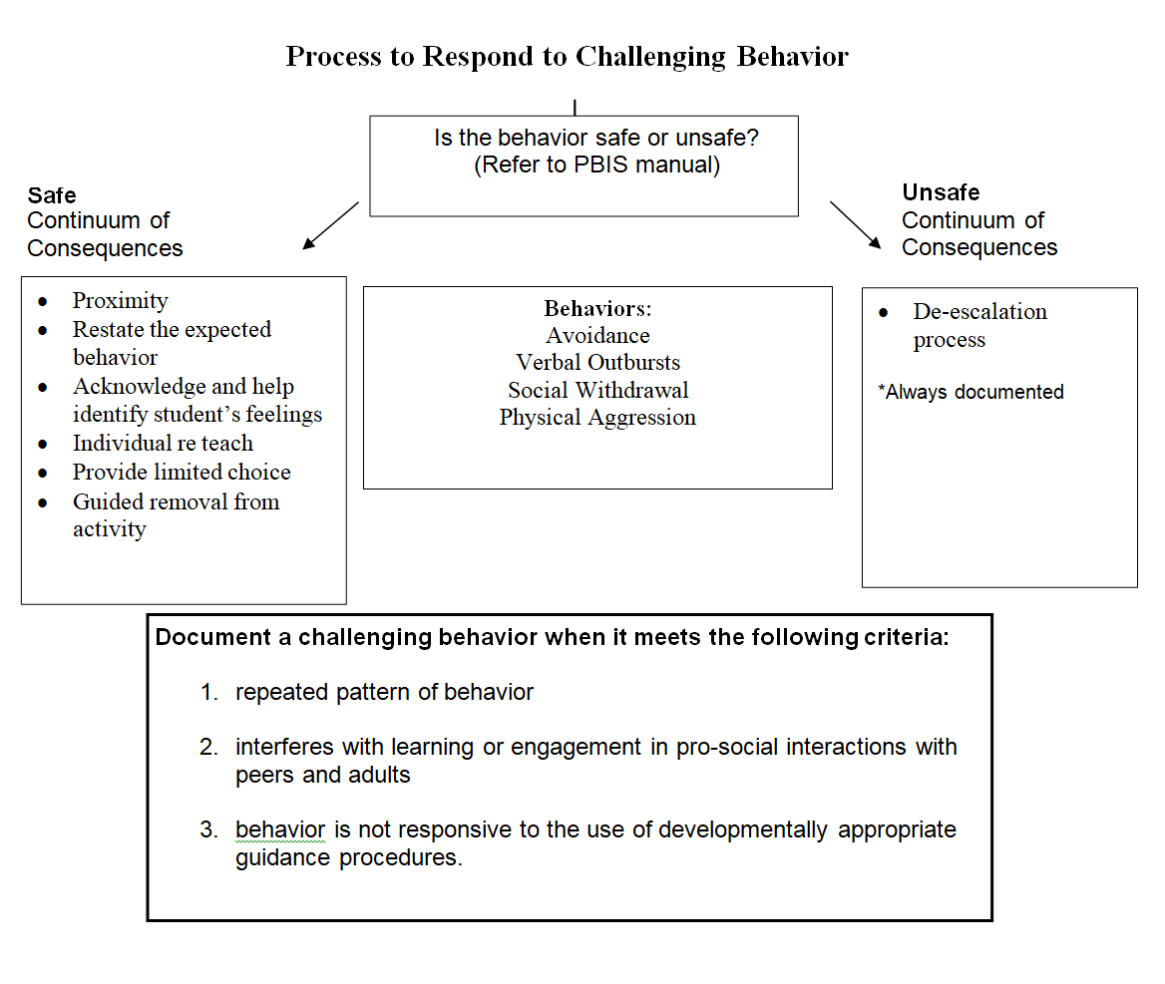

## Continuum of Consequences (Strategies)

* Proximity - staff moves within the area of the student identified as displaying a behavior (Ex: Staff notices behavior of student during snack time. Staff walks over to position their body near the student without any further action.)
* Restate the expected behavior - staff verbally state the specific expected behavior to the whole group or individual student and connect it to one of the building’s overarching expectations (Ex: In the classroom we use walking feet to be Safe.)
* Acknowledge and help identify student’s feelings - staff at student’s eye level in a calm voice acknowledge the student is struggling and help them articulate their feelings (Ex: It looks like you are frustrated with Tommy because he took your shovel.)
* Individual re teach - staff at student’s eye level in a calm voice use one of the teaching methods already provided to the whole class now to the individual child in an abbreviated manner (Ex: Let’s practice how we keep our hands to ourselves while in line to show respect. I will do it first, we will do it together, and then you can show me independently.)
* Provide limited choice - staff at student’s eye level in a calm voice verbally request the child to select from two acceptable choices that address the expectations and rules (Ex: We use scissors for cutting to keep us safe. You may use the scissors on the paper or you can play with the blocks in this area.)
* Guided removal from activity - staff at student’s eye level in a calm voice verbally prompt paired with a visual support or gesture to place the student in a different activity with a reminder of the expected behaviors (Ex: It’s my job to keep you safe. We need to play at the music area with our friends. We are safe in the music area by using the instruments to make sounds.)
* De-escalation techniques – staff approach student with calmness and a neutral facial expression while allowing space for both the staff and student; use of a low and even tone when speaking; acknowledge the student’s feelings; apply a distraction by engaging the student's thinking brain (Reference: <https://blog.optimus-education.com/using-de-escalation-techniques-effectively)>

## Behavior Incident Report & Guidance

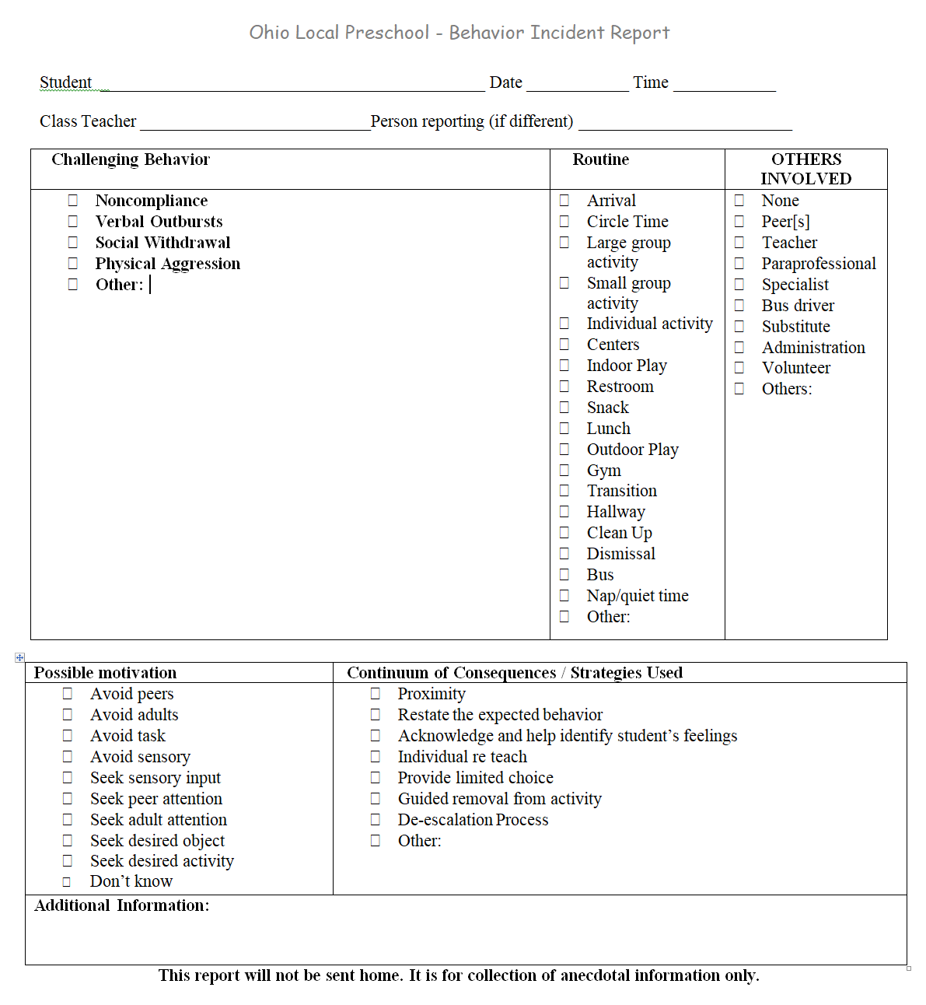

**Behavior Incident Report (BIR) Guidance**

Note: A behavior incident might include multiple behaviors although you will be selecting the behavior that is most intrusive to note on the form. If the behavior incident ends and the child has another one later in the activity or day; complete an incident form for each separate incident.

For safe behaviors that meet the criteria below of a challenging behavior a BIR is to be completed.

1. repeated pattern of behavior (consider frequency, intensity, or duration)
2. interferes with learning or engagement in pro-social interactions with peers and adults
3. behavior is not responsive to the use of developmentally appropriate guidance procedures

For unsafe behaviors that meet any or all of the descriptors a BIR is always to be completed.

* May place self-or others at physical risk
* May prevent the on-going delivery of instruction
* May cause significant property damage

*The challenging behavior event is one that the administration needs to be aware of and/or if the classroom staff need to have help at the moment or after the event from other adults.  Refer to section 3 for specifics on how to receive in the moment support and Ohio Revised Code rules on maintaining ratio for preschoolers.

The electronic form is located on the school’s internal staff website. If not completing at the time of the event, ensure that all information is collected for accurate reporting by the end of the work day in order for instantaneous data.

The specific fields are described below in order to ensure consistent and valid data entry.

**Student** = use the student’s ID number here

**Date** = when the challenging behavior occurred

**Time** = when the challenging behavior occurred

**Class Teacher** = name of the student’s classroom teacher

**Person reporting** = adult that is completing the BIR

**Challenging Behavior** = select the appropriate behavior descriptor for the event and if more than one behavior, select the most intensive only. There is an option to select other if the behavior is unable to be identified with the main behaviors on the BIR.

|  |  |  |
| --- | --- | --- |
| **Behavior** | Definition | Examples (what it might look like / sound like) |
| **Noncompliance** | Refusing to following directions | Running away from an adult or class  Dropping to the ground (limp noodle)  Hiding (under tables, under lockers, etc.)  Refusing to transition (ex- refusing to leave playground) |
| **Verbal outburst** | Verbal actions that cause disruption, are hurtful, or inappropriate that may or may not be directed to a peer and/or adult | Screaming, brief or continued  Name calling  Swearing  threats  Refusal (no, get away) |
| **Social Withdrawal** | Noticeable lack of participation or  interest in social situations with peers and/or adults | Nonparticipation in activities  refusal to interact with adults or peers  Unwilling to try new experiences |
| **Physical Aggression (toward self or others)** | Purposeful action toward self, peers, or adults that could cause harm | Kicking, Biting, Pinching, Hitting, Spitting,  Throwing objects |
| **Other:** |  | Select only if the behavior is unable to be identified with one of the main behaviors above |

**Routine** = refers to the scheduled times during the day; select where the behavior first occurred/started.

|  |  |
| --- | --- |
| Arrival | Student arrives at school for the day |
| Circle Time | Structured large group time at the beginning of the day addressing daily information and routines |
| Large group activity | Structured adult led activity with 7 or more students |
| Small group activity | Planned adult led activity with 2 to 6 students |
| Individual activity | Student is working one on one with an adult or by themselves |
| Centers | Semi-structured play time; includes art, music/movement, dramatic play, writing, blocks, books, sensory, and science inside the classroom. |
| Indoor Play | Gross motor time in the classroom where students are free to choose activities that involve the large motor muscles |
| Restroom | Specified time for individual to be diapered or use toilet |
| Snack | Specified time during the morning to break for eating a snack |
| Lunch | Time in between activities/routines or movement to a different classroom or school environment |
| Outdoor Play | Outdoor area where students are free to choose activities that involve the large motor muscles |
| Gym | Gross motor area where students are free to choose activities that involve the large motor muscles |
| Transition | Time in between activities/routines or movement to a different classroom or school environment |
| Hallway | The public space or corridors between rooms |
| Clean Up | Adult directed activity where students are cleaning up a specific area before they move to next activity |
| Dismissal | Student leaves school for the day |
| Bus | School provided transportation to and from home |
| Nap/quiet time | Specified time during the day when all students are to rest |

**Others Involved** = refers to individuals who are directly affected by the incident. It does not include individuals who were merely present during the incident.

|  |  |
| --- | --- |
| None | No other individuals were involved in the incident |
| Peer[s] | At least one other student is involved |
| Teacher | Any teacher from the building |
| Paraprofessional | Any paraprofessional or teacher aides from the building |
| Specialist | Related services- OT, PT, ST, Behavior Specialist, etc. |
| Bus driver | Person driving bus or assisting with students on the bus |
| Substitute | Any person taking the place of an absent employee |
| Administration | The supervisor of school employees |
| Volunteer | Adult not employed by the school providing assistance in the class or building |
| Other: | Provide title of person not specific names |

**Possible Motivation** = refers to why the student may be exhibiting the behavior

|  |  |
| --- | --- |
| Avoid peers | Student does NOT want peer attention |
| Avoid adult | Student does NOT want adult attention |
| Avoid task | Student does NOT want to do a specific task/activity |
| Avoid sensory | Student does NOT want sensory input |
| Seek sensory input | Student wants/needs sensory input |
| Seek peer attention | Student wants other students to notice him/her |
| Seek adult attention | Student wants adults to notice him/her |
| Seek desired object | Student wants a specific item |
| Seek desired activity | Student wants to do a specific activity |
| Don’t know | Select if unable to determine possible motivation |

**Continuum of Consequence / Strategies used** = refers to how the adult responds and aligns to the flowchart. Select all that were used for the event.

* Proximity - staff moves within the area of the student identified as displaying a behavior (Ex: Staff notices behavior of student during snack time. Staff walks over to position their body near the student without any further action.)
* Restate the expected behavior - staff verbally state the specific expected behavior to the whole group or individual student and connect it to one of the building’s overarching expectations (Ex: In the classroom we use walking feet to be Safe.)
* Acknowledge and help identify student’s feelings - staff at student’s eye level in a calm voice acknowledge the student is struggling and help them articulate their feelings (Ex: It looks like you are frustrated with Tommy because he took your shovel.)
* Individual re teach - staff at student’s eye level in a calm voice use one of the teaching methods already provided to the whole class now to the individual child in an abbreviated manner (Ex: Let’s practice how we keep our hands to ourselves while in line to show respect. I will do it first, we will do it together, and then you can show me independently.)
* Provide limited choice - staff at student’s eye level in a calm voice verbally request the child to select from two acceptable choices that address the expectations and rules (Ex: We use scissors for cutting to keep us safe. You may use the scissors on the paper or you can play with the blocks in this area.)
* Guided removal from activity - staff at student’s eye level in a calm voice verbally prompt paired with a visual support or gesture to place the student in a different activity with a reminder of the expected behaviors (Ex: It’s my job to keep you safe. We need to play at the music area with our friends. We are safe in the music area by using the instruments to make sounds.)
* De-escalation techniques – staff approach student with calmness and a neutral facial expression while allowing space for both the staff and student; use of a low and even tone when speaking; acknowledge the student’s feelings; apply a distraction by engaging the student's thinking brain

**Additional Information** =space to add brief statements that may later act as reminders of certain details. This is not a required field and may not be necessary in all situations.

## Guidance on the Process for Data Collection for Data Based Decision Making

* Staff will complete the electronic BIR form located on the school’s internal staff website.
* If not completing at the time of the event, ensure that all information is collected for accurate reporting by the end of the work day in order for instantaneous data.
* All data is entered daily by the end of the work day.
* Tier 1 PBIS team data manager is responsible for generating graphs from the electronic BIR form’s excel sheet which reflect the monthly building wide data by date, time, location, and challenging behavior. This will be inserted into the agenda by the Monday before the T1 PBIS team meeting which is the 3rd Friday of the month.
* Each Tier 1 PBIS team member will review the data graphs in the agenda prior to the PBIS meeting.
* Data reviewed at the monthly PBIS meeting will use the following questions to analyze the data:
  + For all data presented a base question will be first, is the data accurate?
    - Are all staff putting information into the system with consistency?
  + Are there trends that can be identified?
  + Identify possible needs and use the data to develop a precise problem statement
    - What is the problem (and how often is it occurring)?
    - Where is the problem happening?
    - Who is engaged in the problem?
    - When is the problem most likely?
    - Why is the problem being sustained?
  + Team priorities needs and identifies an action step.
    - Team may decide that more information/data is needed to develop an action step.
  + When reviewing action steps, team will address:
    - Are we doing what we said we were going to do?
    - Is it making a difference?